Salesforce Administrator Self-Learning & Super Badges

Sub heading :- Data Management

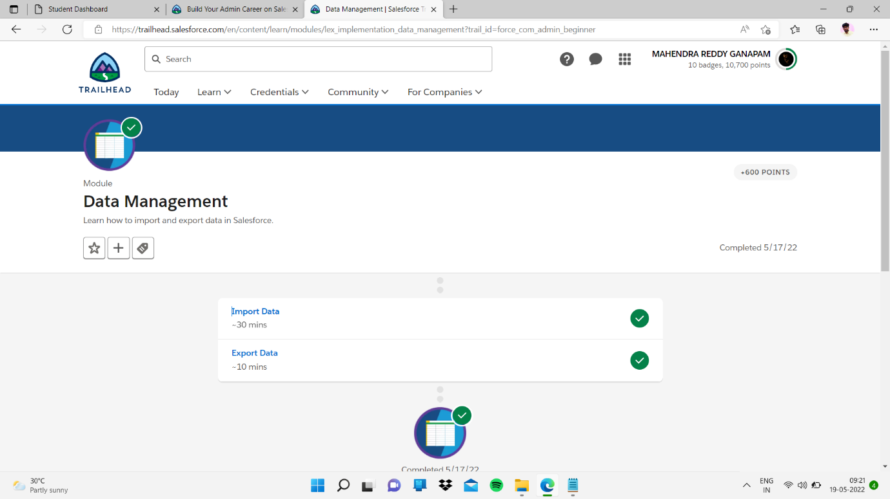

Sub topic :- import data

My task :-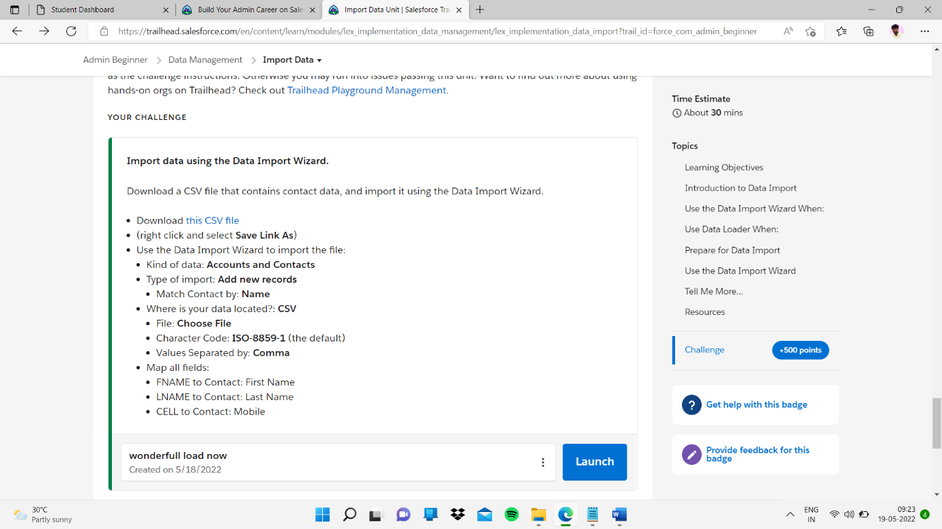

And I successfully completed

